Evaluation: Random Forest
Accuracy: 0.966
Precision: 0.966021134446044
Recall: 0.966
F1 Score: 0.9659968654219491
Jaccard Index: 0.9345956740572615
Matthews CorrCoef: 0.9575067025703771
Cohen’s Kappa: 0.9575
Specificity: 0.9914999999999999
AUC: 0.9981270000000001
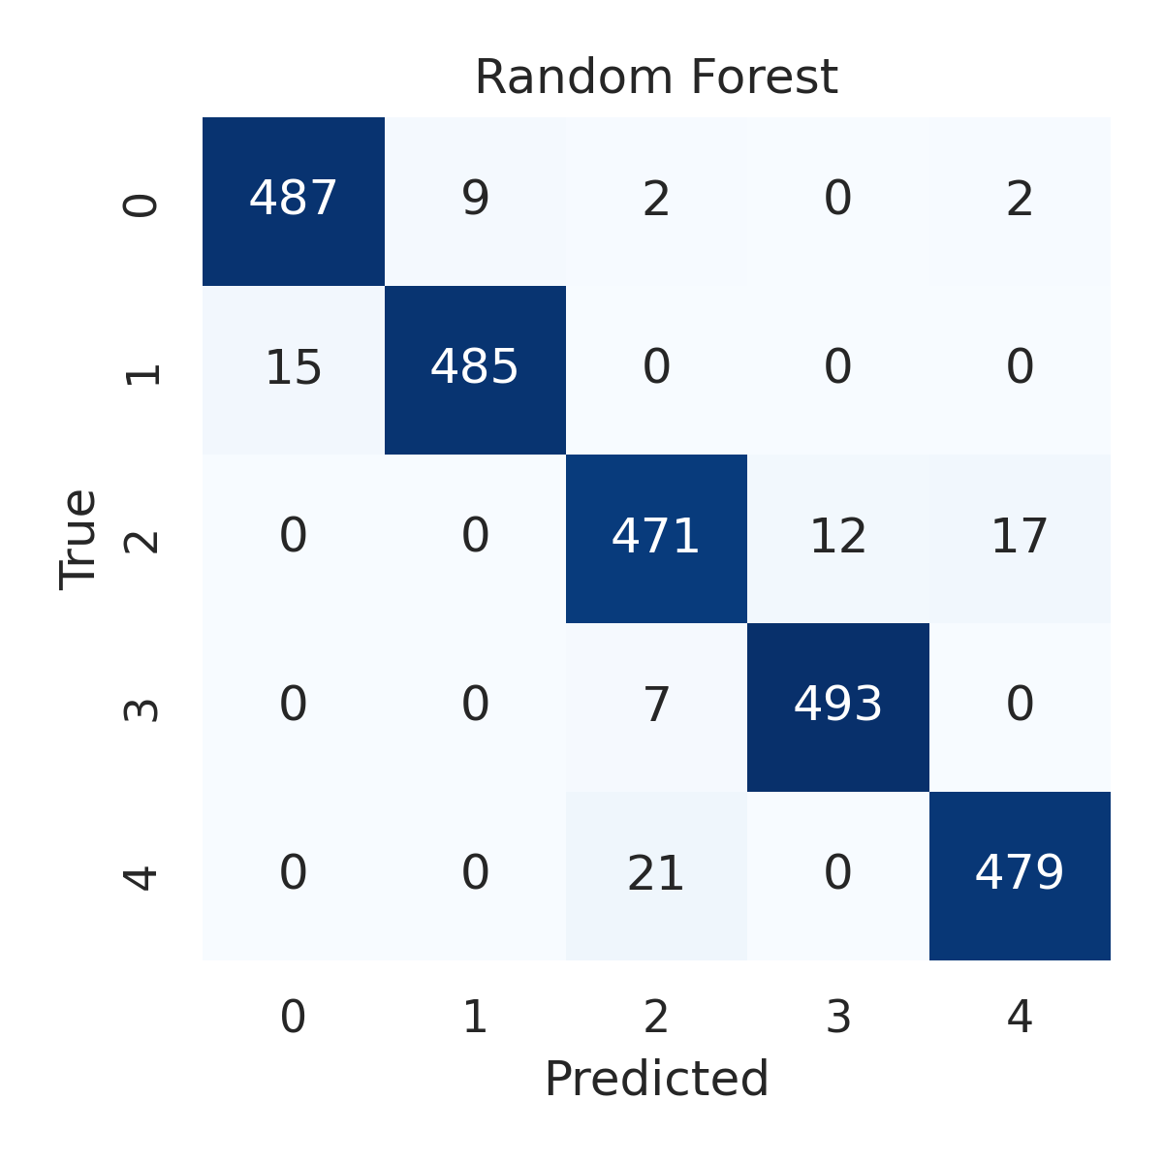

Combined ROC Curves
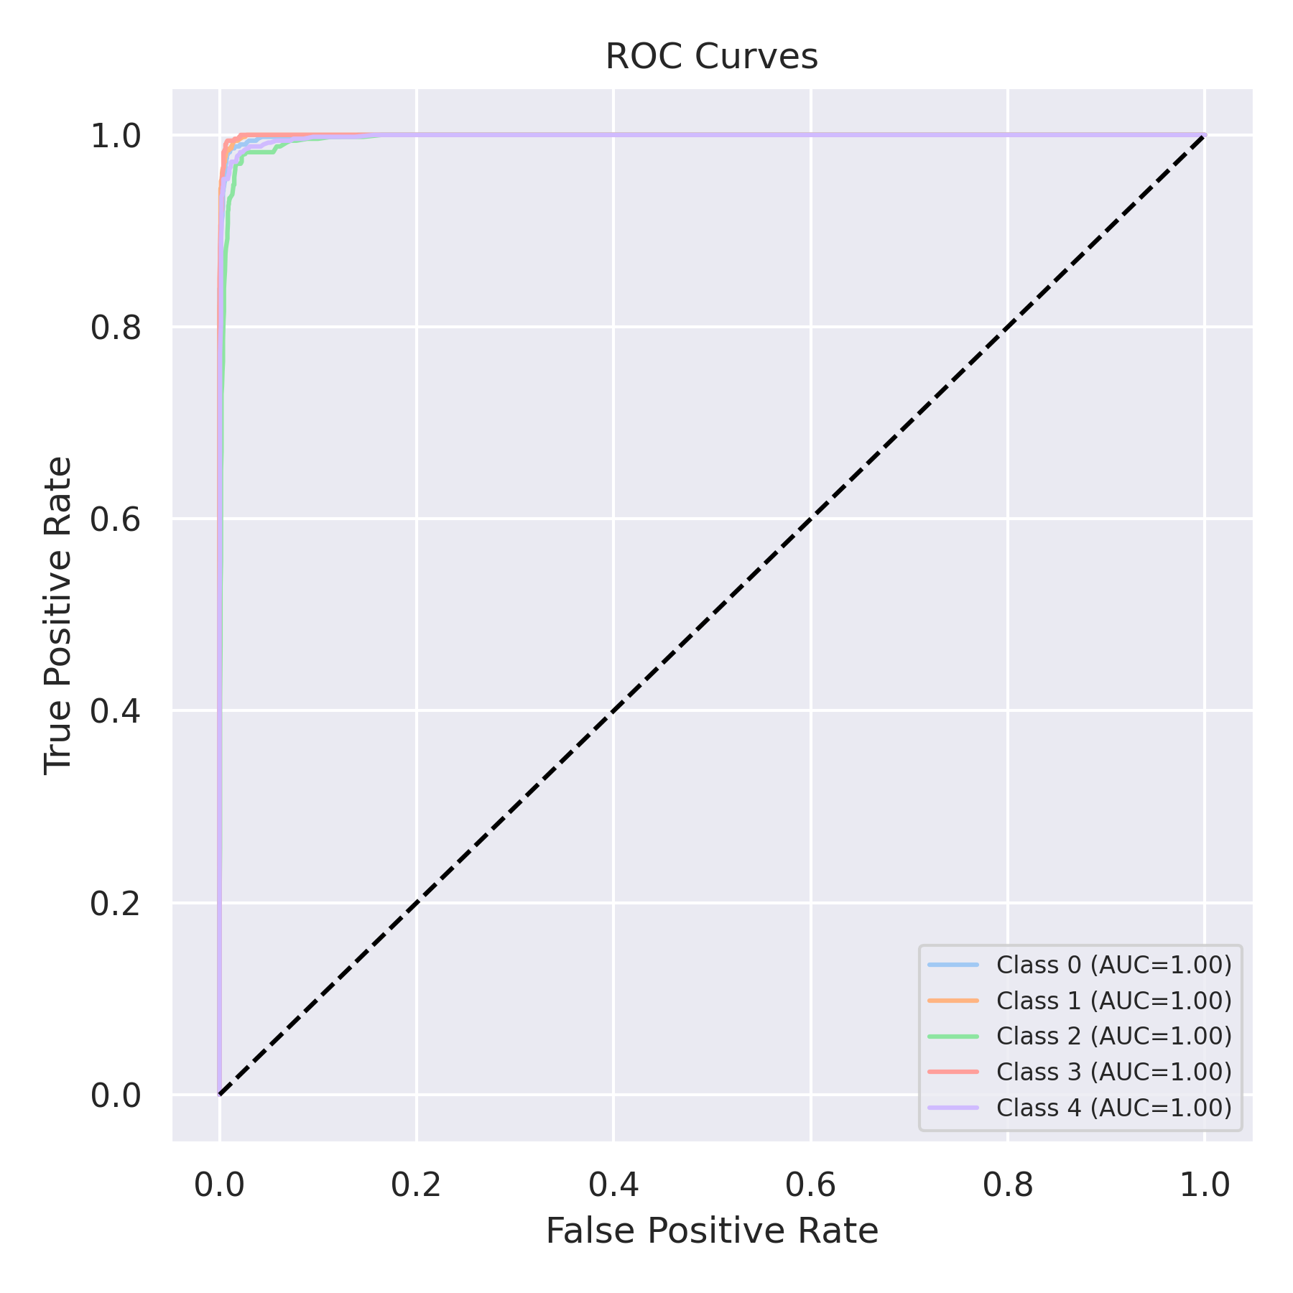

Evaluation: K-Nearest Neighbors
Accuracy: 0.8844
Precision: 0.8858241402989064
Recall: 0.8844
F1 Score: 0.8834473893799004
Jaccard Index: 0.7929033144844714
Matthews CorrCoef: 0.8562989571350202
Cohen’s Kappa: 0.8555
Specificity: 0.9711000000000001
AUC: 0.986577
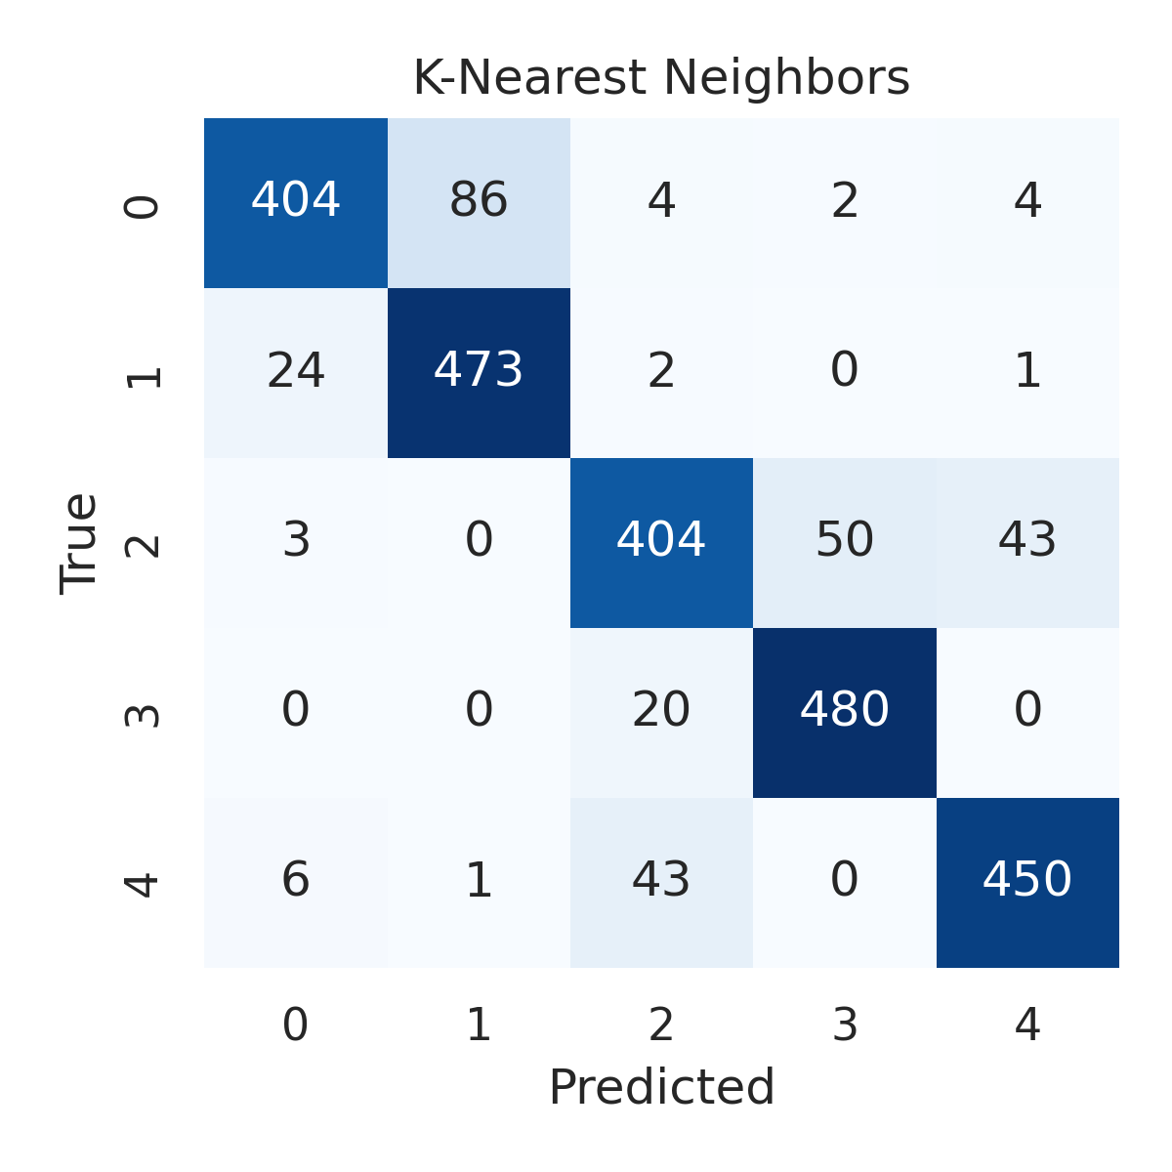

Combined ROC Curves
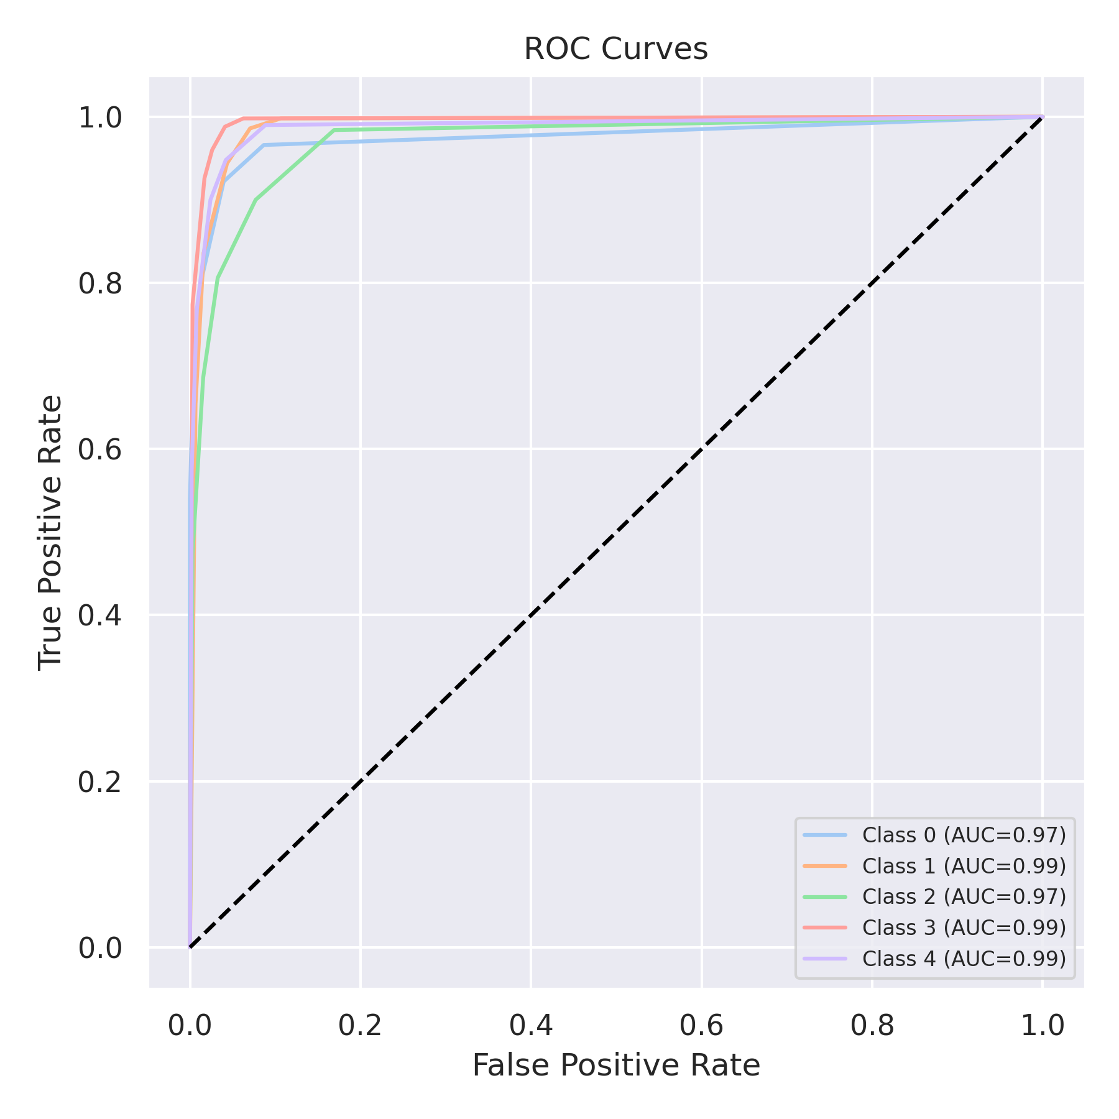

Evaluation: Decision Tree
Accuracy: 0.9596
Precision: 0.9596847311984431
Recall: 0.9596
F1 Score: 0.959638185975341
Jaccard Index: 0.9230415942302519
Matthews CorrCoef: 0.9495020889068934
Cohen’s Kappa: 0.9495
Specificity: 0.9899000000000001
AUC: 0.96575
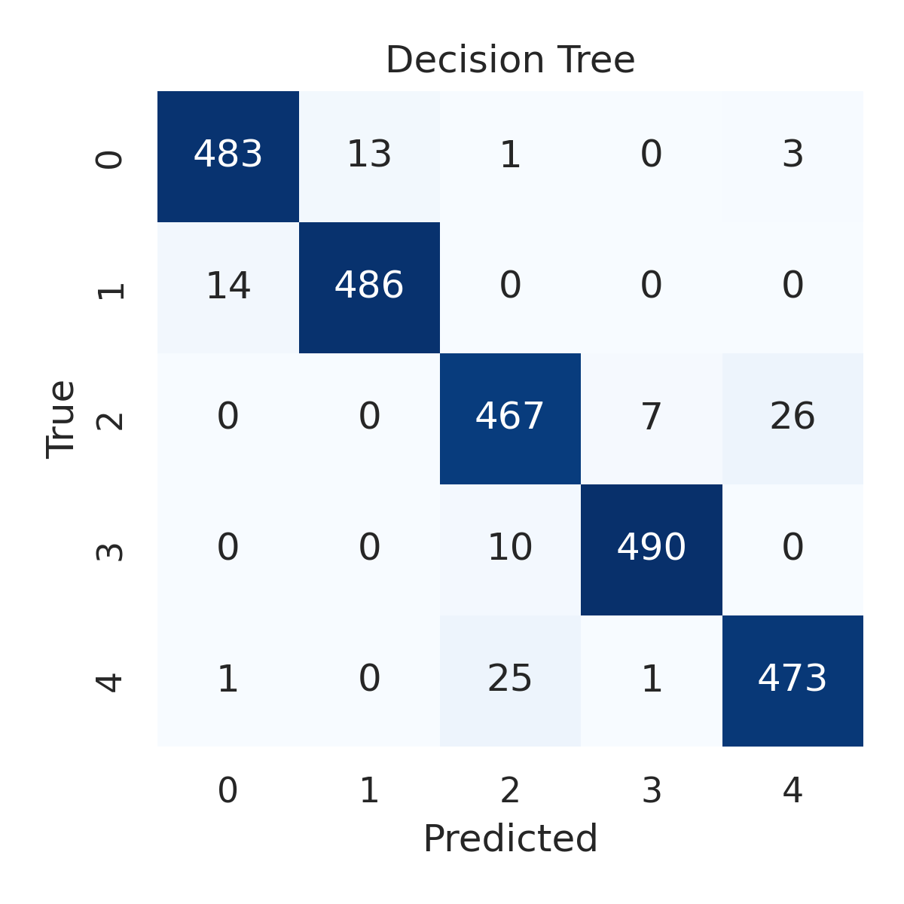

Combined ROC Curves
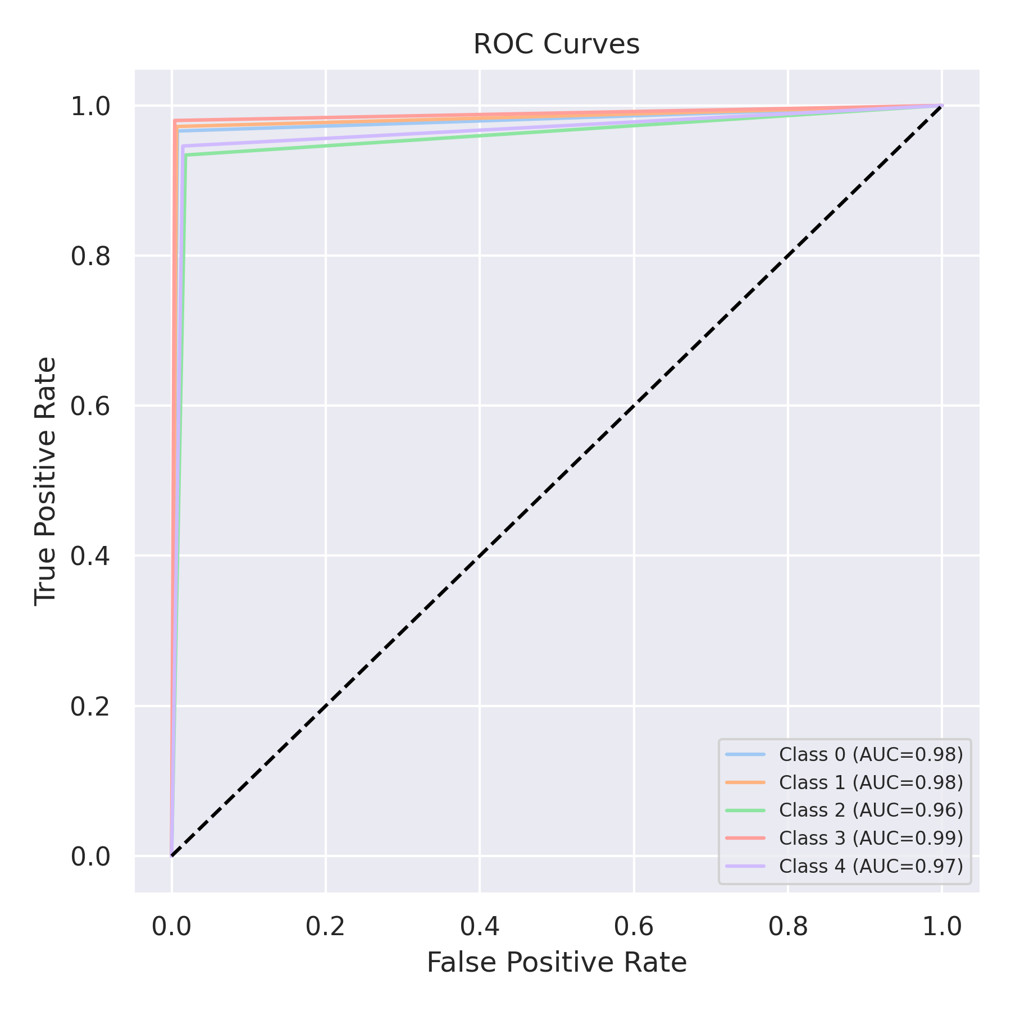

Evaluation: Extra Trees
Accuracy: 0.97
Precision: 0.970042781212846
Recall: 0.97
F1 Score: 0.969995398504066
Jaccard Index: 0.9419699683428946
Matthews CorrCoef: 0.9625127052515645
Cohen’s Kappa: 0.9625
Specificity: 0.9925
AUC: 0.9985365
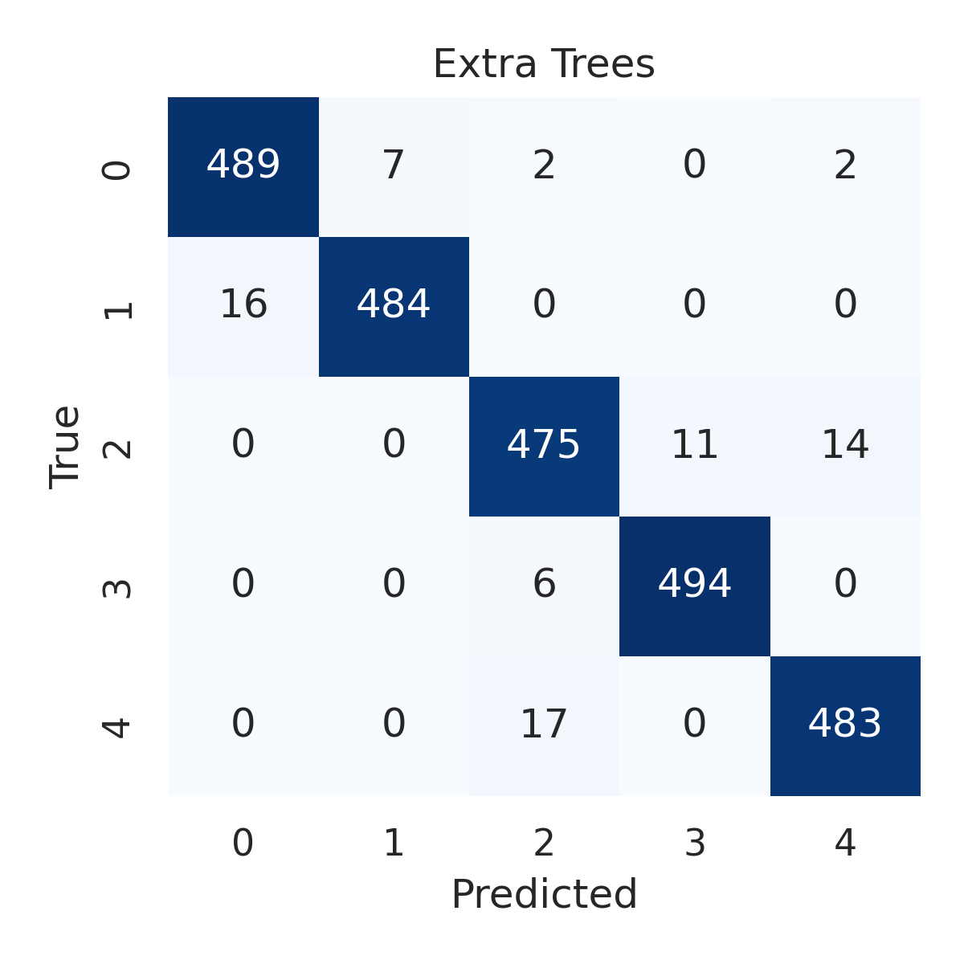

Combined ROC Curves
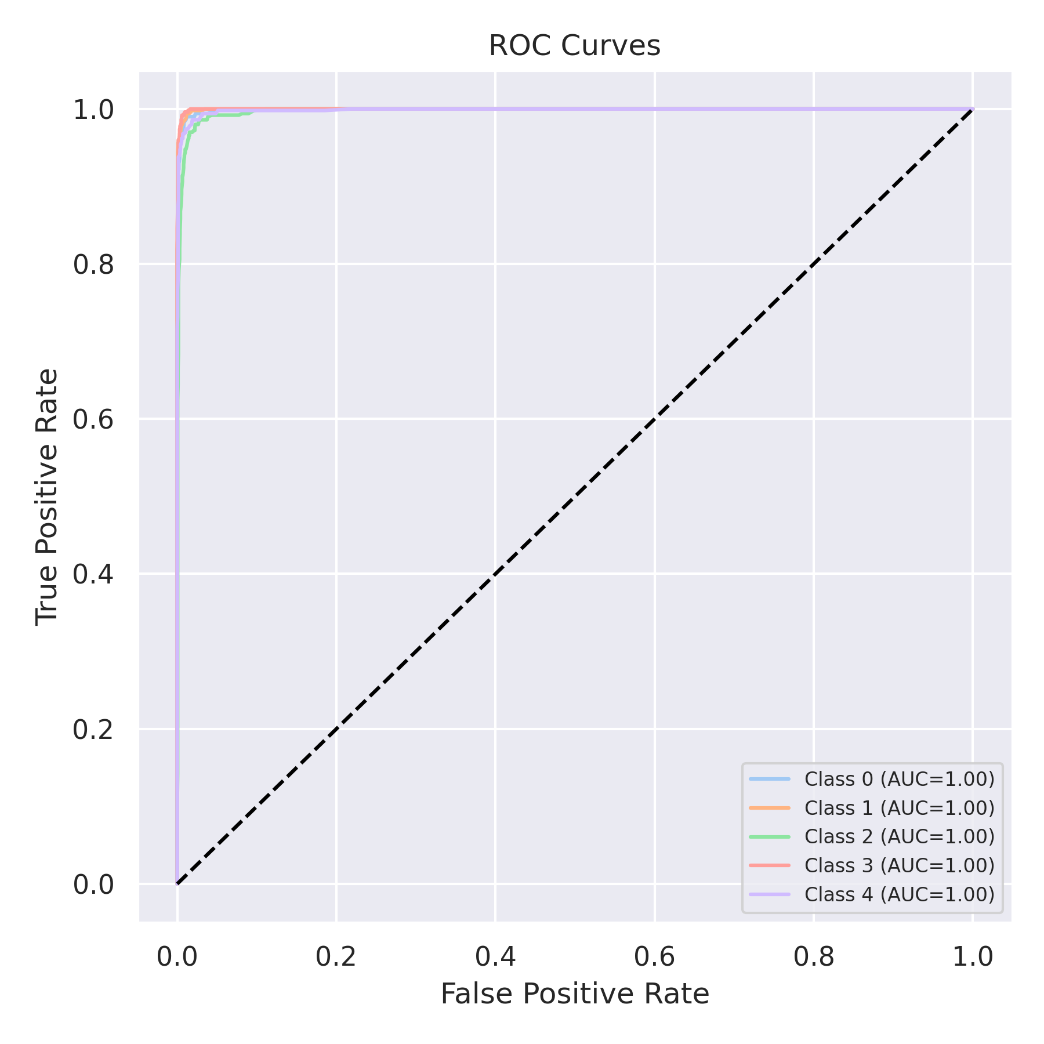

Evaluation: Bagging Classifier
Accuracy: 0.9732
Precision: 0.9734904190844876
Recall: 0.9732
F1 Score: 0.9732754276295407
Jaccard Index: 0.9482674271711873
Matthews CorrCoef: 0.9665357624848301
Cohen’s Kappa: 0.9665
Specificity: 0.9933
AUC: 0.994965
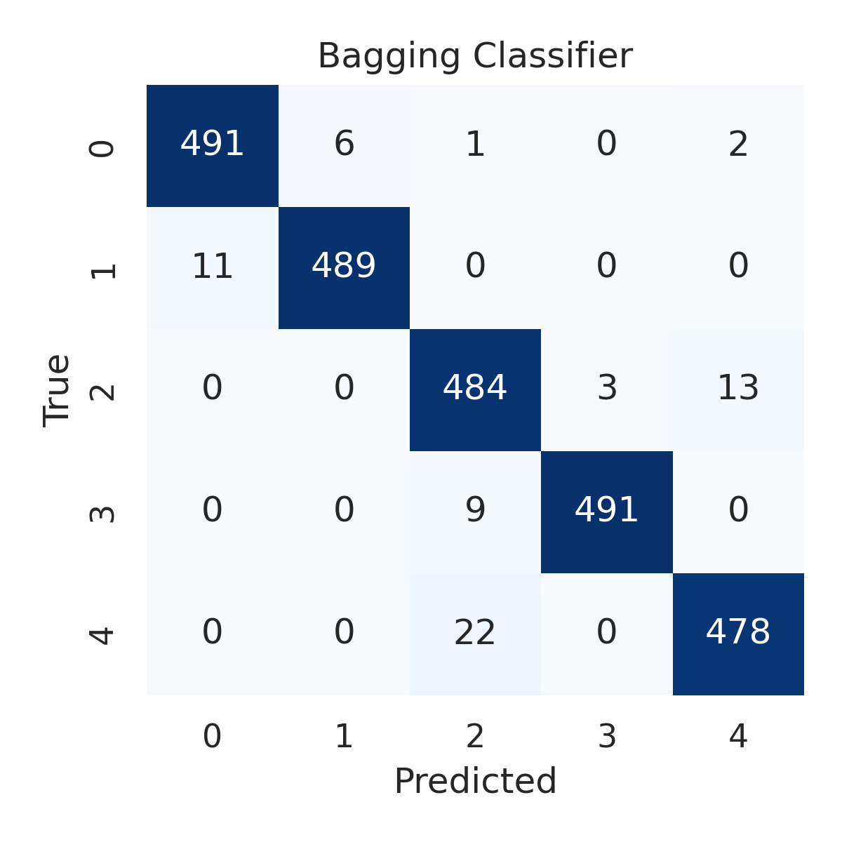

Combined ROC Curves
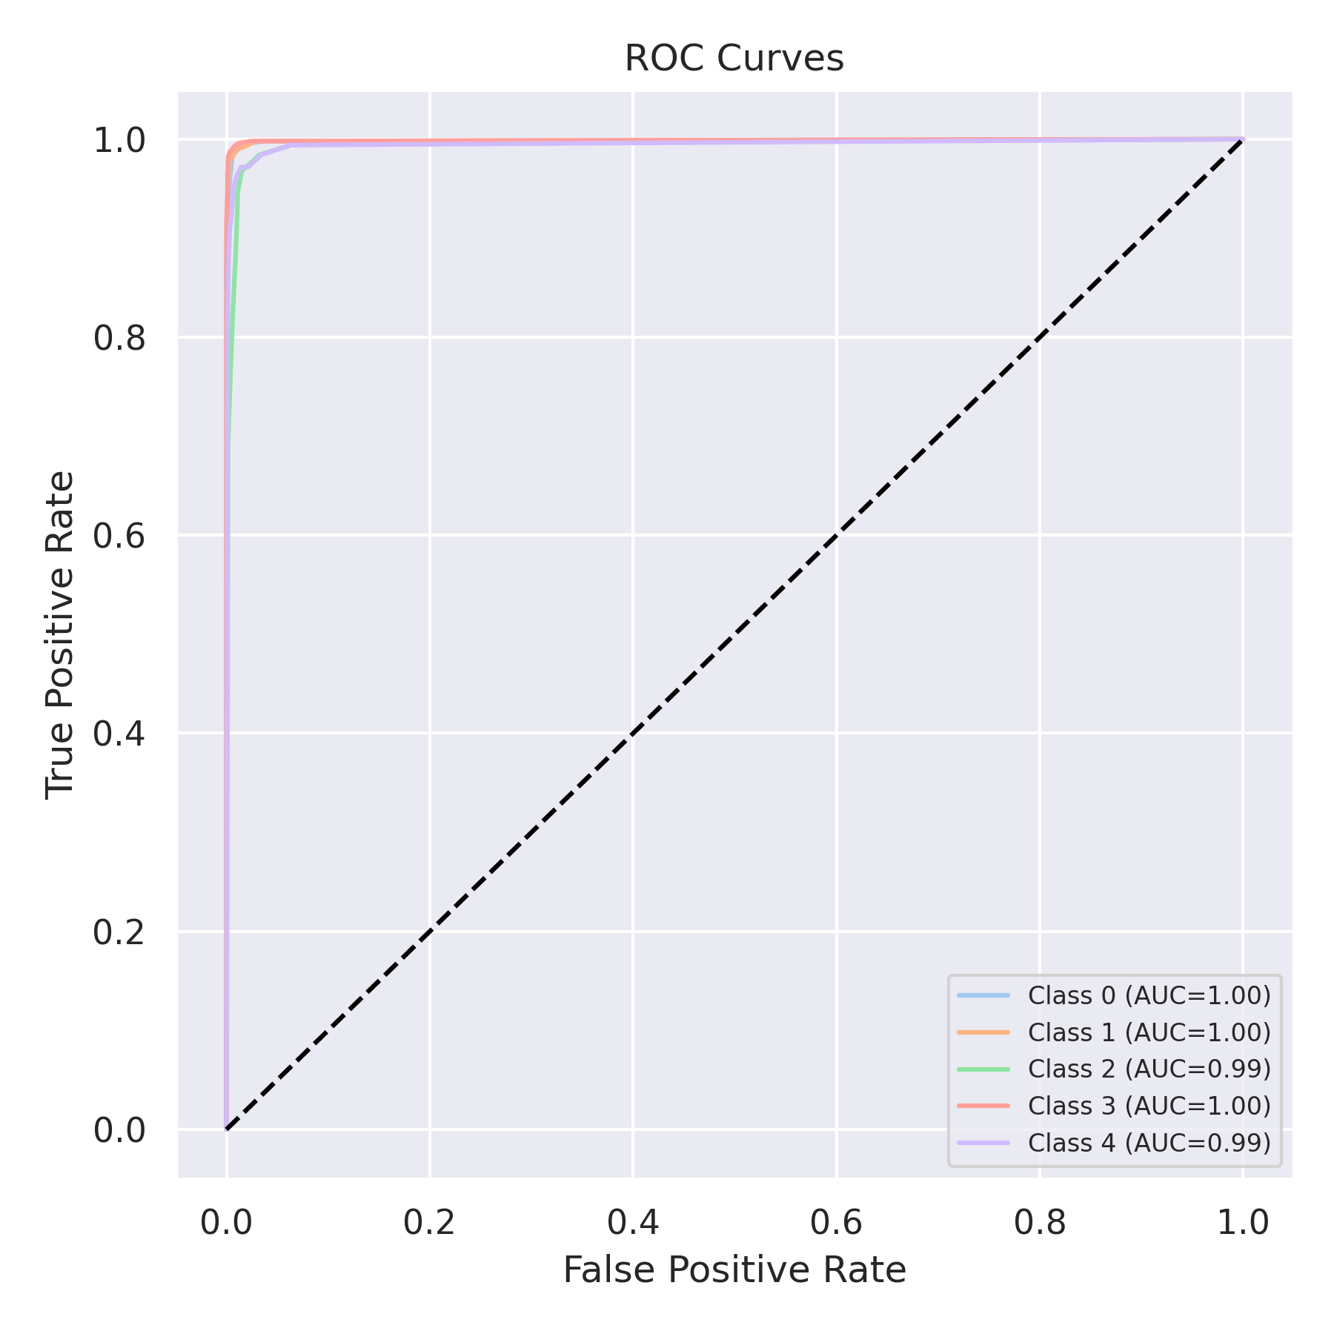

Evaluation: XGBoost
Accuracy: 0.9816
Precision: 0.9816605091146232
Recall: 0.9816
F1 Score: 0.9816071004114026
Jaccard Index: 0.9639745756098924
Matthews CorrCoef: 0.9770115288040603
Cohen’s Kappa: 0.977
Specificity: 0.9954000000000001
AUC: 0.9994000000000001
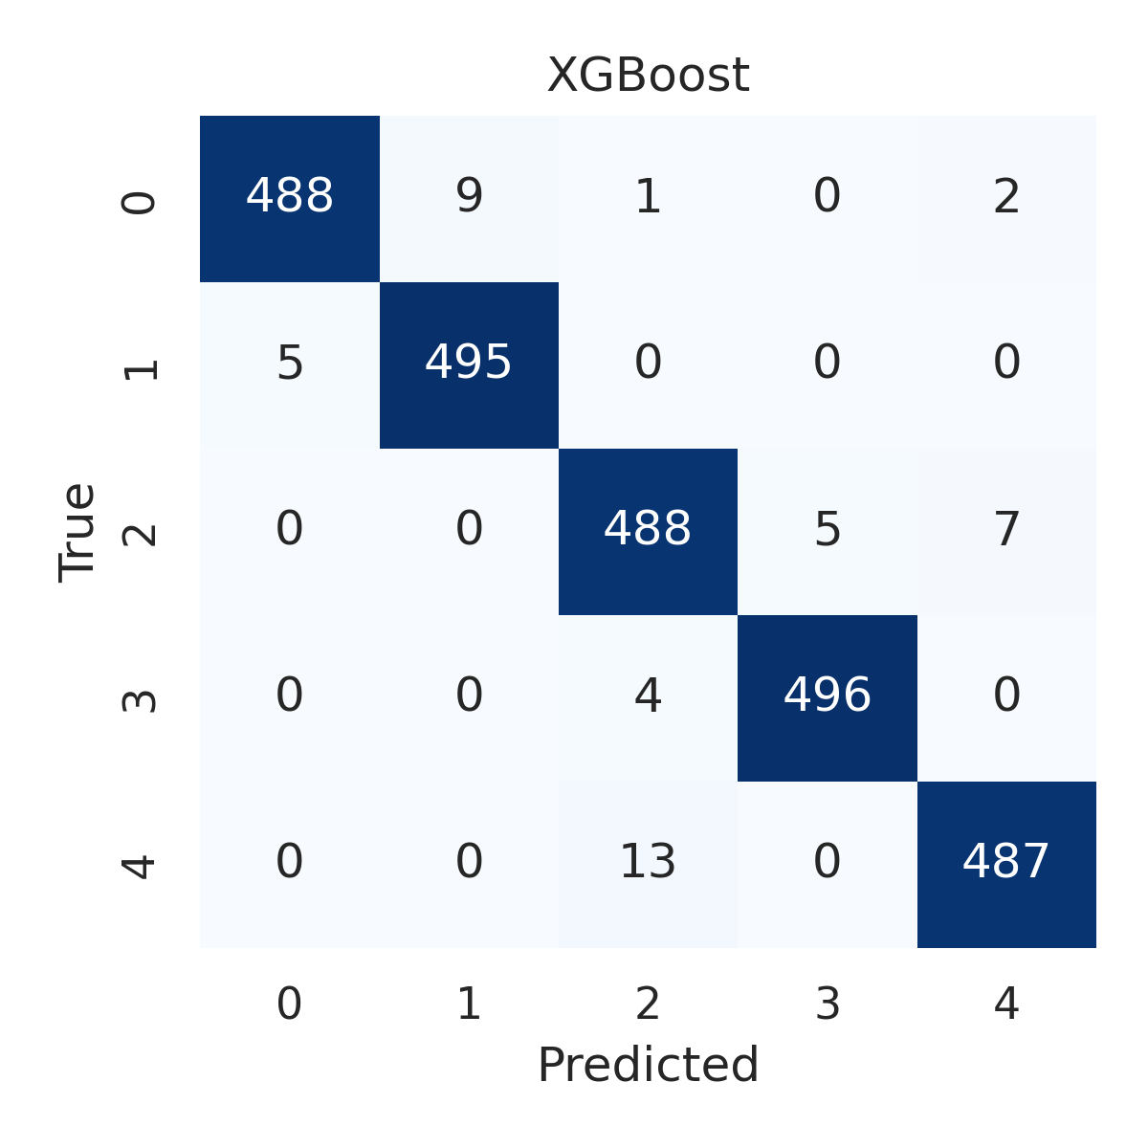

Combined ROC Curves
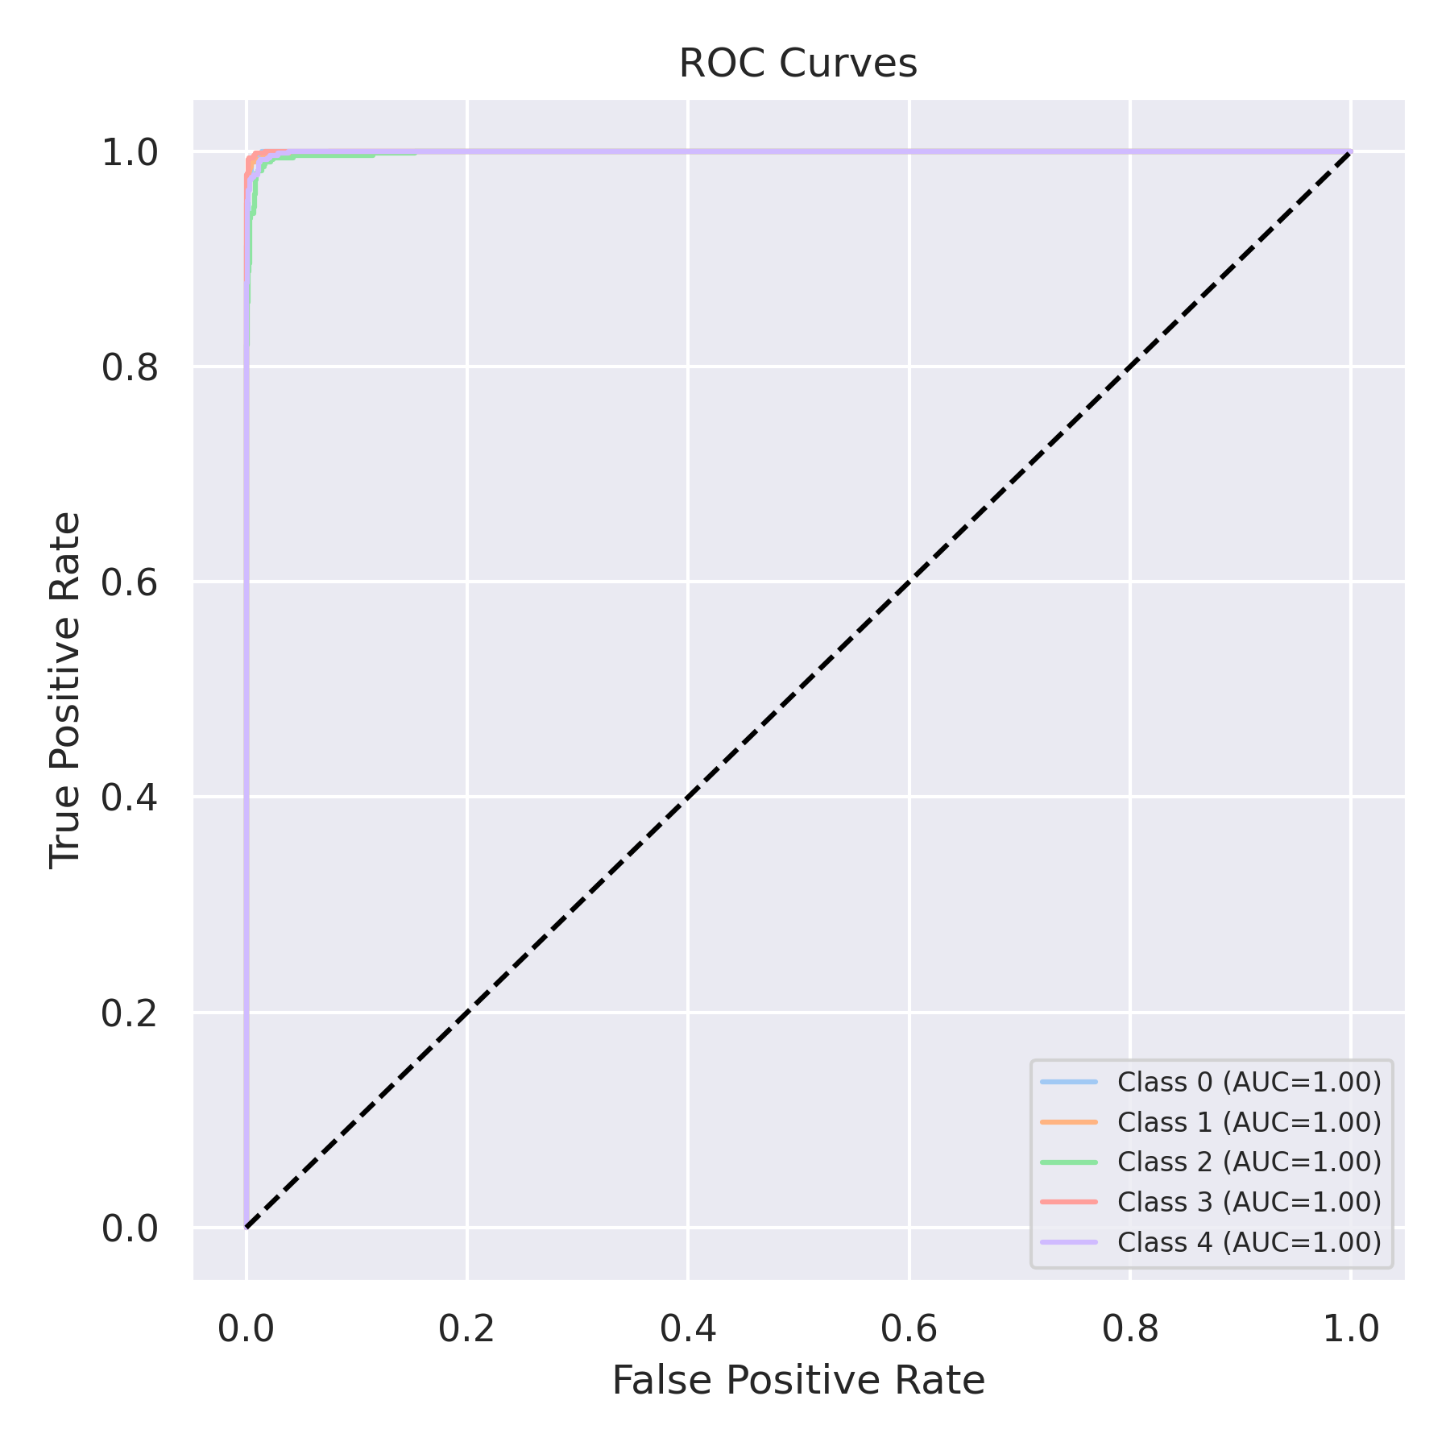

Evaluation: LightGBM
Accuracy: 0.9804
Precision: 0.9804691944596945
Recall: 0.9804
F1 Score: 0.9804175353060751
Jaccard Index: 0.9617203493115758
Matthews CorrCoef: 0.9755085845133157
Cohen’s Kappa: 0.9755
Specificity: 0.9951000000000001
AUC: 0.999521
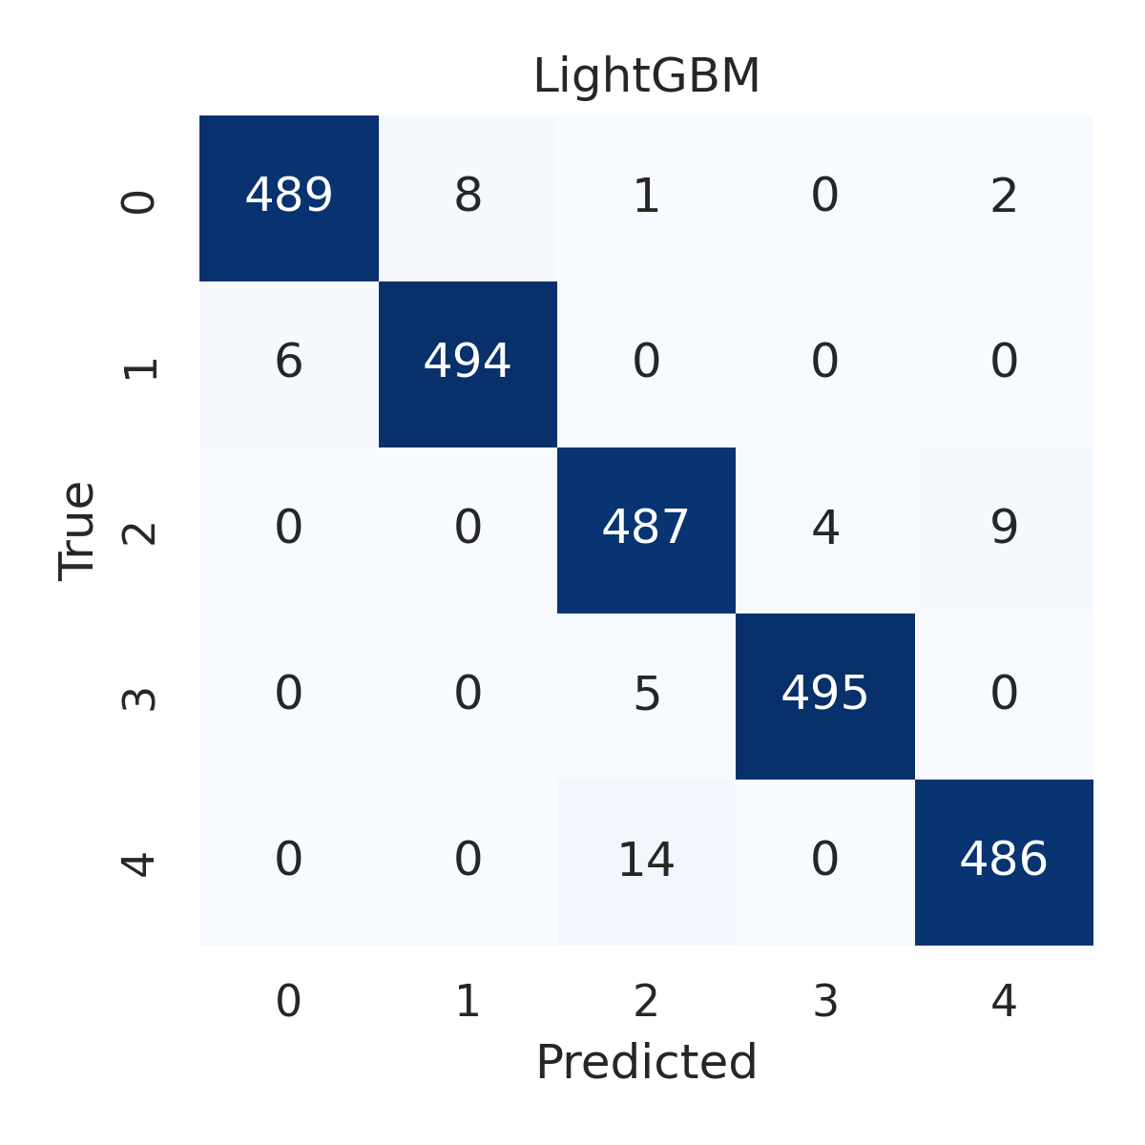

Combined ROC Curves
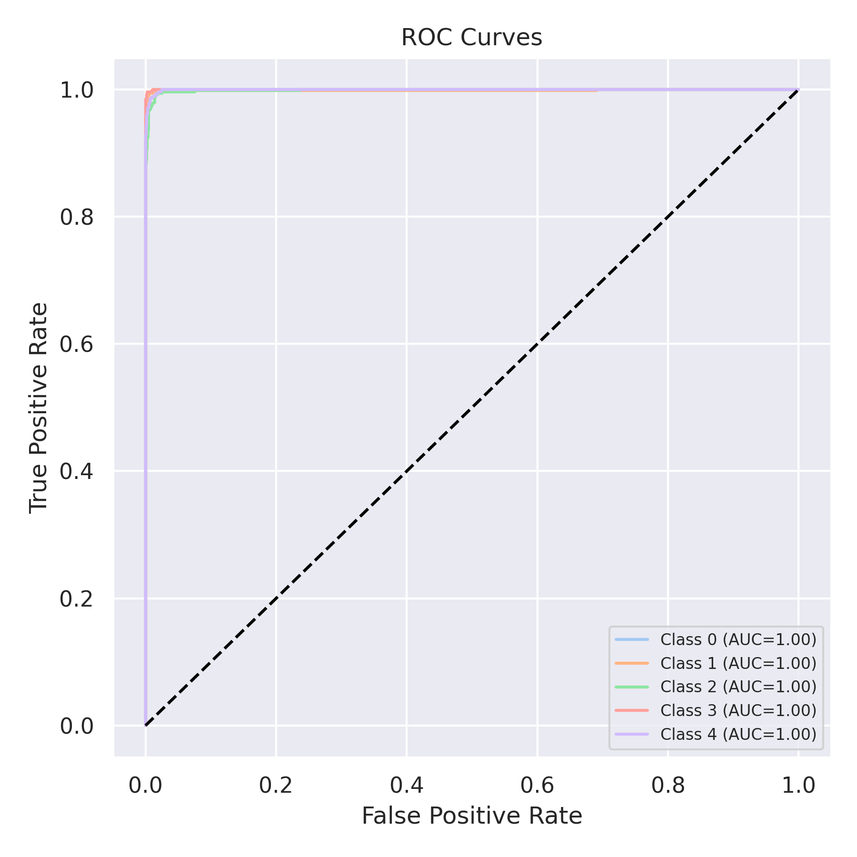

Evaluation: CatBoost
Accuracy: 0.2
Precision: 0.04
Recall: 0.2
F1 Score: 0.06666666666666667
Jaccard Index: 0.04
Matthews CorrCoef: 0.0
Cohen’s Kappa: 0.0
Specificity: 0.8
AUC: 0.99916
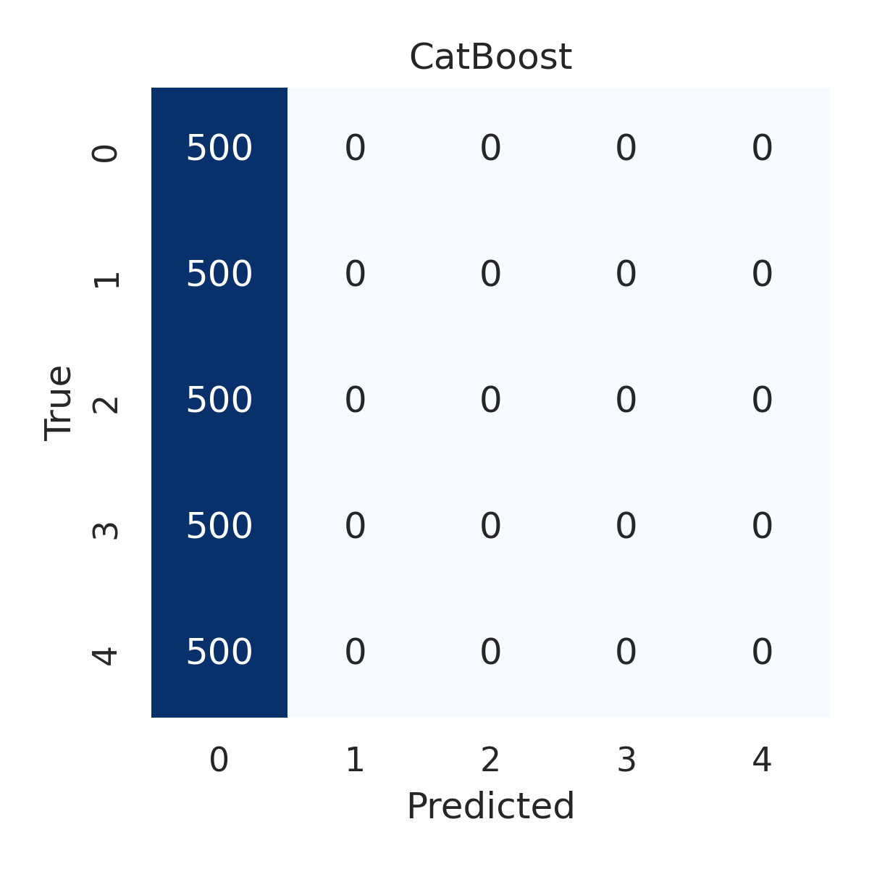

Combined ROC Curves
